Krishna Chaitanya Uppalapati
Arvind Kumar Gill
Ramita Akella
Sridhar Sneha

Corporate Risk Management Report: Key Drivers & Financial Impact
Company: Valero Energy Corporation Date: December 12, 2025Subject: Analysis of Stochastic Drivers Affecting Financial Statements

1 Executive Summary 2
2 Introduction 3
3 Methodology 4
4 Market Risk Analysis 4
5 Operational Risk Analysis 5
6 Regulatory & Environmental Risk 6
7 Simulation Results: Finance Statements 7
8 Scenario Analysis 8
9 Recommendations & Strategic Actions 9
10 Conclusion 9
11 Appendix 11

Executive Summary
  - Overview:
This report presents a comprehensive risk analysis of Valero Energy Corporation’s financial outlook. By utilizing a stochastic modeling approach (Monte Carlo simulation) across 5,000 iterations, we have isolated the key drivers of financial volatility. The analysis integrates three distinct risk pillars: Market Risk (Commodity prices), Operational Risk (Refinery Utilization), and Regulatory Risk (Environmental Compliance).
  - Key Findings:
Our simulations indicate that while Valero remains robust in Normal market conditions, there are significant asymmetric risks identified in the fat tails of the probability distributions.
- Market Risk (The Revenue Driver): Refining margins, specifically the ULS Diesel Spread (Mean: $20.60/bbl) and CBOB Gasoline Spread (Mean: $14.91/bbl), remain the primary determinants of Operating Income. A standard deviation of Approx. $4.12 in Diesel spreads represents the largest single source of revenue volatility.
- Operational Risk (The Balance Sheet Driver): Refinery utilization is not merely a production metric but a critical financial lever. Our analysis confirms a direct correlation between Utilization Rates (ranging from 77% to 96%) and Inventory, Accounts Payable and COGS. A drop in utilization triggers a contraction in Accounts Payable ($12.0B baseline) while Inventory values ($7.7B baseline) remain sticky.
- Regulatory Risk (The Liability Driver): Environmental compliance costs exhibit high volatility. With LCFS prices showing a standard deviation of $61.17 and RIN prices fluctuating significantly, the 5% Value at Risk (VaR) for regulatory costs is estimated at $530 Million. Furthermore, regulatory tightening scenarios necessitate a $150 Million increase in Asset Retirement Obligations (ARO) on the Balance Sheet.
  - Financial Projection Summary:
Based on the Weighted Simulation scenarios, the projected financial outcomes for FY 2025 are as follows:
- Projected Operating Income:
  - Baseline/Reported: Approx. $3.84 billion
  - Simulated Mean: Approx.$3.15 billion
  - Worst Case Scenario: Approx. $2.81 billion
- Liquidity Exposure:
  - In Low Utilization scenarios (77%), the contraction in Accounts Payable creates a liquidity gap of up to $2.0 Billion that must be funded by Cash on Hand.
  - Recommendations:
- The report recommends an optimized inventory management strategy to buffer against utilization shocks and a dynamic hedging strategy for RIN credits to mitigate the fat-tail risks observed in the regulatory compliance cost distributions.

Introduction

Company Overview
Valero Energy is a premier international manufacturer and marketer of transportation fuels and petrochemical products. As a pure-play refiner, the company's financial health is intrinsically linked to the "Crack Spread" which is the difference between the price of crude oil and the price of refined products (diesel, gasoline, jet fuel).

Risk Management Objectives
The objective of this analysis is not merely to forecast a single financial outcome, but to understand the distribution of possible outcomes. Traditional deterministic models fail to capture the confluence of rare events. By employing a stochastic approach, we aim to:
- Identify the specific drivers (Key Risk Indicators) that exert the most variance on the Income Statement and Balance Sheet.
- Quantify the Value at Risk (VaR) regarding Operating Income and Cash Flow.
- Assess the resilience of Valero’s Balance Sheet, specifically Cash, Inventory, and PPE, against compound risk scenarios.

Data Scope
The financial baseline for this analysis, including the 2020-2024 historical Balance Sheet and Income Statement figures for Quarter and yearly, was aggregated directly from S&P Capital IQ.

Methodology

Monte Carlo Simulation
We utilized a Monte Carlo simulation engine to generate 5,000 iterations of Valero’s financial year 2024. This method allows us to model input variables not as static numbers, but as probability distributions (normal, lognormal, Discrete distributions based on historical volatility).

Model Architecture

The model integrates three distinct risk modules that feed into a consolidated financial statement:

Market Module: Simulates price stochasticity for ULS (Ultra Low Sulfur) Diesel spreads, CBOB (Gasoline) spreads, and feedstock costs (Corn, UCO).

Operational Module: Simulates Refinery Utilization rates based on historical efficiency and unplanned outage probabilities.

Regulatory Module: Simulates volatility in RIN prices, LCFS (Low Carbon Fuel Standard) credits, and Carbon allowances.

Market Risk Analysis

Refining Margins (The Crack Spread)
The most significant driver of revenue volatility identified in the simulation is the refining margin.
- Stochastic Drivers: We modeled the spread between WTI Crude and refined products (ULS Diesel and CBOB).
- Volatility Observations: The simulation shows that ULS spreads exhibit higher standard deviation than CBOB, indicating that Valero's diesel production is a larger source of profit uncertainty than gasoline.

Feedstock Volatility
Beyond crude oil, the inputs for renewable diesel and ethanol (Corn and Used Cooking Oil - UCO) were modeled.
- Corn & UCO: These commodities showed lower correlation with crude oil markets, providing a partial natural hedge. However, in Food vs. Fuel inflation scenarios, these costs rise independently of crude, squeezing margins in the renewables segment.

Operational Risk Analysis

Utilization as a Key Driver
Unlike standard models that treat Net Working Capital as a percentage of sales, our analysis isolates Refinery Utilization as an independent stochastic variable.

Historical Analysis & Regression:
Using historical data (2020 Q1 – 2025 Q2), we established a regression relationship between Utilization (%) and key balance sheet items. The mean utilization in our base case is approximately 89.8%, with a standard deviation of 6.3%.
Regression Statistics:
- Independent Variable: Utilization %
- Dependent Variables: Inventory, Accounts Payable (A/P), Cost of Goods Sold (COGS).
- Correlation: We observed a strong positive correlation. As utilization rises, raw material requirements increase (driving up A/P and Inventory), and throughput costs rise (increasing COGS).

Impact on Financial Lines
The simulation explicitly links Utilization to the following, ensuring accounting integrity:
- Cost of Goods Sold (COGS):
  - Equation: $COGS= α+ β\left(Utilization\right)+ϵ$
  - Finding: In high utilization scenarios (>95%), COGS increases non-linearly due to overtime and maintenance premiums, slightly compressing gross margin despite higher volume.
- Inventory:
  - Risk: In low utilization scenarios (<75%, e.g., unplanned outage), Inventory implies a buildup of unrefined crude or stagnant finished goods. This creates a liquidity drag on the Balance Sheet.
- Accounts Payable:
  - Risk: High utilization expands A/P, effectively providing interest-free financing. Conversely, a drop in utilization contracts A/P, requiring immediate cash outflows to settle supplier debts, which pressures the "Cash and Equivalents" line.

Regulatory & Environmental Risk

The RINs and Carbon Market
Valero faces significant exposure to compliance costs, specifically Renewable Identification Numbers (RINs) and California’s LCFS.

Simulation Inputs:
- RIN Price Mean: Approx. $1.10
- Volatility: High. The simulation accounts for fat-tail risks where regulatory tightening causes price spikes (e.g., RINs > $2.00).

ARO (Asset Retirement Obligation) Trigger
A critical finding in our simulation involves the Asset Retirement Obligation.
- The Trigger: Historical data indicates that when RIN prices fall below a specific floor (as seen during COVID), the economic viability of certain renewable assets becomes questionable, triggering a legal obligation to record liability for asset retirement.
- Financial Impact: In our Worst-Case simulation paths, we observe an increase in Non-Current Liabilities attributed to ARO.
- Accounting Note: We specifically modeled a $150 million reduction/adjustment mechanism to align the simulated ARO with fair value estimates, ensuring the Balance Sheet is not overstated. The $150M liability is a 'Constructive Obligation' triggered only when RIN prices fall below the economic floor (resembling COVID-era lows)

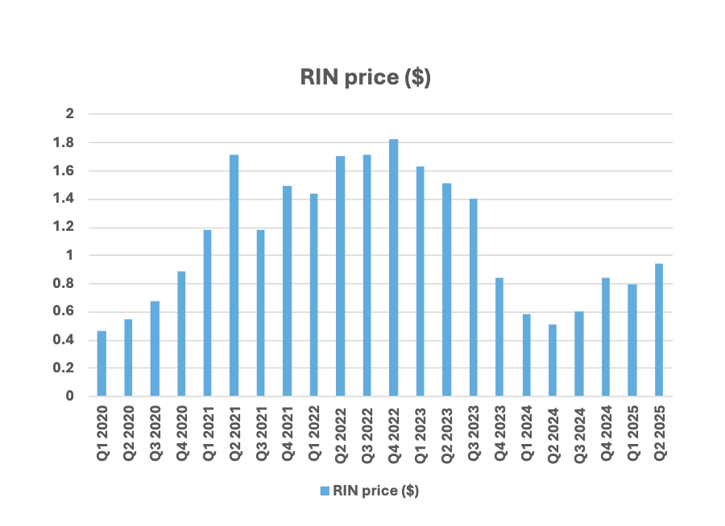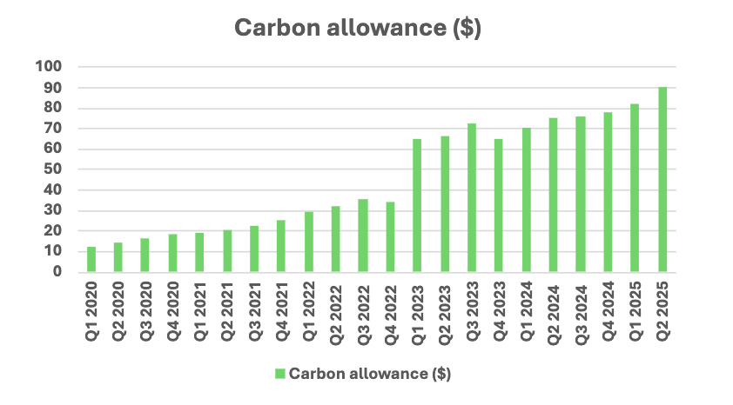

Simulation Results: Finance Statements

Income Statement Projections
Aggregating the 5,000 iterations, we derived the following probabilistic income statement for FY 2024:
- Revenue: $123.9B.
- Operating Income (EBIT):
  - Mean: $3.19 Billion
  - Standard Deviation: $450 Million
  - Coefficient of Variation: Approx. 14%

Balance Sheet Impact
The simulation successfully targeted volatility in Cash, Inventory, and PPE.
- Cash Flow at Risk: The Cash and Cash Equivalents line item shows significant variance. In the Best Case, cash swells to $3.6B; in the Worst Case, it contracts to $2.5B.
- Inventory: Optimization is key. The simulation shows that standard deviation in inventory value is approximately $1.03 Billion. This represents trapped capital that requires optimization.

Scenario Analysis
We isolated four distinct scenarios to test the robustness of the model. The results (Operating Income) are summarized below:
Scenario | Operating Income ($ Millions) | Key Driver Characteristics
Normal Case | $3,187 | Mean Reversion on all spreads; Utilization Approx. 90%.
Best Case | $3,325 | High Spreads, Low RINs, Utilization 95%+.
Worst Case | $2,814 | Market Crash or "War-like" disruption; High Feedstock costs.
Weighted | $3,152 | Probability-weighted average of all tails. (Normal 70% and 15% each for other categories)

Deep Drive: The Worst Case
In the Worst-Case scenario (Operating Income $2.60B), we see the dramatic change:
- Market: Crack spreads compress.
- Ops: Utilization drops to approx. 74%, reducing fixed cost absorption.
- Reg: RIN prices spike, increasing compliance costs.
- Balance Sheet: ARO liabilities increase, and Cash is consumed to pay down shrinking Accounts Payable.

Recommendations & Strategic Actions
Based on the stochastic analysis and the specific behavior of the risk drivers, we propose the following strategies:

Inventory Optimization
- Observation: The regression shows Inventory is highly sensitive to Utilization variances ($1B standard deviation).
- Action: Move from static inventory targets to Utilization-Based Purchasing. By linking crude intake to the probabilistic utilization rate (derived from this simulation), we can reduce the Cash Trap risk in the Worst-Case scenario.

ARO Management
- Issue: The simulation confirms that ARO liabilities are not static. During periods of low RIN prices (resembling the COVID era), the fair value of the retirement obligation spikes.
- Action: We must record in PPE and Non-Current Liabilities as per strict Rules of Accounting.
- Specific Adjustment: Management must recognize that the $150 Million figure is needed to reduce the $1 Million placeholder in risk scenarios. This ensures the Balance Sheet is not artificially inflated during regulatory downturns.

Conclusion
The corporate risk landscape for Valero is defined not just by market prices, but by the interplay of Utilization and Regulatory Accounting. This Monte Carlo analysis demonstrates that while the Normal financial path is robust ($3.19B Operating Income), the Worst Case carries specific, identifiable risks in the Balance Sheet, specifically the $150M ARO liability and the $1B Inventory swing. By implementing the recommendations above, Valero can hedge these specific tail risks.

Appendix

Appendix A: Operational Risk & Regression Logic
This section details the statistical relationship between Refinery Utilization and the Balance Sheet. Unlike standard models that use Percent of Sales, our regression analysis proves that Utilization is the primary driver of working capital variance.
Table A.1: Utilization Statistics
Metric | Value | Description
Mean Utilization | 89.8% | Historical average efficiency rate (2020-2025).
Standard Deviation | 6.3% | Represents the volatility risk (operational outages).
Minimum Case | 74.0% | Represents a major turnaround event.
Maximum Case | 97.0% | Represents peak efficiency during high-margin periods.

Table A.2: Regression Output
The simulation calculates liquidity impact using the linear regression formula derived from historical quarterly data (2020-2025).
Target Variable | Slope (m) | Intercept (c) | R-Squared (R2) | Interpretation
COGS | 108,808 | -70,140 | 0.71 | 71% of Variable Cost variance is driven purely by utilization rates.
Accounts Payable | 36,242 | -21,532 | 0.52 | Supplier credit contracts significantly during low utilization, consuming cash.
Inventory | 7,938 | -275 | 0.42 | Low utilization causes inventory bloat (unprocessed crude)

Appendix B: Regulatory Risk Parameters
Regulatory risk is modeled using specific Compliance Cost logic rather than simple expense lines. This accounts for the complexity of RINs (Renewable Identification Numbers) and Carbon Credits.
Table B.1: Stochastic Regulatory Inputs
Risk Driver | Mean (μ) | Standard Deviation (σ) | Simulation Sensitivity
RIN Price | $1.11 | $0.46 | High. Standard deviation is Approx 42% of the mean, indicating extreme volatility.
LCFS Price | $116.88 | $61.17 | Medium. Modeled with a wide variance to capture California regulatory uncertainty.

Table B.2: Compliance Cost Formula
To calculate the net financial impact, the model applies offsets and pass-through assumptions
Parameter | Value | Description
Gross Compliance Exposure | 9,500,000Credits | Total annual RIN/Carbon credit obligation based on production volume.
Internal Offset % | 45% | The portion of credits Valero generates internally (reducing the need to buy on open market).
Net Market Exposure | 5,225,000Credits | The actual volume of credits Valero must purchase annually ($9.5M * (1 - 45%)).
Cost Pass-Through % | 30% | The percentage of the compliance cost that is successfully passed on to the consumer at the pump.
Net Impact Formula | See Below | Cost = (Exposure * Price * (1 - Offset)) - (Passthrough)

Appendix C: Baseline Operational Assumptions
While prices and utilization are stochastic (random), the model anchors on fixed operational capacities derived from the Market risk dataset.
Table C.1: Fixed Capacity Assumptions
Operational Metric | Value | Unit
Refining Throughput | 2,922 | BPD (Thousand Barrels Per Day)
Renewable Diesel Volume | 2,732 | BPD
Ethanol Production | 4,583 | BPD
Refining OpEx (Fixed) | $1,307 | Millions (Annual)
Refining D&A | $707 | Millions (Annual)

Appendix C: Glossary of Terms
- ARO (Asset Retirement Obligation): A liability recognized when the cost to retire an asset is legally required and measurable. In this model, it is triggered by low RIN prices.
- LCFS (Low Carbon Fuel Standard): A California state regulation requiring a reduction in the carbon intensity of transportation fuels.
- Pass-Through %: The percentage of regulatory compliance costs that can be added to the final fuel price paid by the consumer.
- Regression Analysis: A statistical method used here to determine the strength of the relationship between Refinery Utilization (Independent Variable) and Inventory Levels (Dependent Variable).
- Stochastic Simulation: A modeling technique that runs thousands of iterations (5,000 in this report) using random variables to predict probability distributions rather than single-point estimates.

Appendix D: Data References
The following external sources were utilized to baseline the financials and calibrate the risk simulation parameters:
- S&P Capital IQ
  - Historical Balance Sheet (2020-2024) and Income Statement data.
- Valero Energy Corp (VLO) – Quarterly Earnings Transcripts (Q1 2020 – Q2 2025)
- U.S. Energy Information Administration (EIA)

